This study investigated differences in sensitivity to nitrate of soybean (Glycine max cv. Davis) symbioses with 16 different Rhizobium japonicum strains. When nitrate (20 mM) was added to established symbioses, there were no significant differences in the degree of inhibition of acetylene reduction for any of the 16 strains. When nitrate was present during the establishment of nodules, high levels of nitrate (10 mM) were equally inhibitory on all symbioses, whereas specific strain effects appeared at low (0.5 mM) to medium (2.0 mM) levels of nitrate. At 1.5 mM nitrate in solution culture, the days to emergence of nodules varied from less than 10 (CB:1809, Nit61A118) to more than 16 (11 of 16 strains). In a clay-pot trial maintained at the low nitrate level (0.5 mM), symbioses with CB:1809 increased total nodule mass by 30% relative to nitrate-free controls. In the presence of 2.0 mM nitrate, CB:1809 maintained total nodule mass. For the remaining 6 strains tested, total nodule mass decreased to below the levels of the nitrate-free controls. In a separate clay pot trial, CB:1809 increased its competitive ability relative to USDA: 110 when nitrate was added. If no nitrate was added, CB:1809 occupied 0.97 times as many nodules as USDA:110; when 10 mM nitrate was added, CB:1809 occupied 1.75 times as many nodules as USDA:110. Attempts to select nitrogen-adapted substrains of R. japonicum through sequential isolation and infection of plants grown on nitrate were not successful.
Externally applied nitrate generally inhibits nitrogen fixation in well-nodulated legume systems (3, 9, 11). Nevertheless there may be beneficial effects from "starter nitrogen" applied before the establishment of an effective symbiosis (17, 19). Once the symbiosis becomes well established, added nitrogen usually does not increase growth or fixation in soybeans (18) or a variety of other legumes (3). Added nitrate appears to substitute for, rather than augment, fixed nitrogen and does not increase yields above the level obtained with adequately nodulated symbiotic plants (8, 9, 12).
If symbiotic plants did not revert from fixed nitrogen to soil nitrogen, more nitrogen would be added to and less removed from the cropping system. The resultant increase in residual soil nitrogen could benefit non-fixing components of the system. This suggests that one approach to achieving greater nitrogen fixation gains by soybeans is to select strains of Rhizobium japonicum which produce symbioses less affected by external nitrate or which recover more rapidly from such effects. The existence of such strains has been suggested for Lupinus angustifolius (10, 13), Medicago sativa (7), and Trifolium subterraneum (3). The existence of R. japonicum strains less susceptible to nitrate inhibition of fixation and the way that these strains interact with their host plants is still problematic (4).

647
APPLIED AND ENVIRONMENTAL MICROBIOLOGY, Sept. 1982, p. 647-652 Vol. 44, No. 3 0099-2240/82/090647-06$02.00/0
Copyright © 1982, American Society for Microbiology
Variations in Ability of Rhizobium japonicum Strains To Nodulate Soybeans and Maintain Fixation in the Presence of Nitrate

DAVID L. McNEIL

University of Hawaii, Department of Agronomy and Soil Science, NifTAL Project, Paia, Maui, Hawaii 96779 Received 15 January 1982/Accepted 18 May 1982
In this work, two techniques were used to confirm the existence of, select, and describe R. japonicum strains which can produce symbioses less affected by external nitrate. In the first method, strains of R. japonicum from the NifTAL collection were screened for continued fixation in established symbioses after the addition of nitrate. In the second method, strains were screened for nodule development, and isolations were made from the nodules which developed in the presence of high external nitrate. The effects of nitrate on symbioses arising from these strains were determined.

MATERIALS AND METHODS

Growth conditions. The growth medium for all experiments was Broughton and Dilworth (1) nitrogenfree nutrient solution modified as indicated for each experiment with KN0₃. Preliminary experiments growing soybeans with different levels of nitrate determined the level appropriate for the effect desired. Experiments were conducted under natural lighting in an evaporatively cooled greenhouse which ranged in
648 McNEIL

temperature between 20 and 35°C. Unless otherwise specified, cv. Davis soybeans were used throughout.
First selection and testing procedure. Duplicate growth pouches, each containing two Glycine max cv. Davis plants, were inoculated individually with 16 effective R. japonicum strains from the NifTAL culture collection. To identify symbioses that were less affected by nitrate, the plants were individually screened for acetylene reduction 0, 1, and 5 days after the addition of 20 mM KNO₃. The two least affected (CB:1809 [USDA:136b] and INTA:E45) and the two most affected (USDA:110, USDA:500) strains were then tested in a more detailed study to determine the usefulness of the screening method.
Soybeans grown in 15 cm diameter clay pots were inoculated with 2 ml of broth culture (10⁹ bacteria per ml) from each of the four selected strains. The growth medium was quartz sand rinsed daily with 150 ml of nitrogen-free nutrient solution (1). After 21 days, half of the pots were given nutrient solution containing 10 mM KN0₃, whereas the other half were watered as before. At 35 days and thereafter, all of the pots received nitrogen-free nutrient solution. Harvests of 5 plants per treatment were made after 21, 25, 32, 36, and 41 days of growth. The plants were harvested individually, and top, nodule, and root dry weights and acetylene reductions were determined (14).
Second selection and testing procedure. To identify strains that produced nodules in the presence of continously applied nitrate, the number of days until the appearance of first nodules was determined in solution cultures containing 1.5 mM nitrate. Soybean seeds were germinated in sterile vermiculite and then transferred to aerated, covered, and sterilized jars that contained 2 liters of nutrient solution with or without 1.5 mM KN0₃. The root systems were then lifted from the jars daily and visually examined for nodules. At the commencement of the experiment, each jar contained two plants and approximately 10¹⁰ rhizobia. Initially, four plants were tested with each of 16 strains of R. japonicum with and without nitrate. Those strains that formed nodules with nitrate within 16 days from inoculation were tested further on 12 more plants. In all experiments, the nitrate level was tested (2) and adjusted daily and did not fall below 1 mM.
Competition study. A peat-based inoculant containing three strains of rhizobia spanning the range of responses found in the second selection procedure was used in a competition study in the presence of different nitrate levels. Seeds were inoculated with approximately 5.0 x 10⁹ bacteria per seed by using a gum arabic sticker (6) and were grown in sand pots. Four levels of nitrate were applied in the nutrient solution throughout growth. For the first 21 days these nitrogen levels were 0, 0.2, 1.0, and 10 mM KN0₃. From 22 to 29 days the 0.2 mM level was increased to 0.5 mM, and the 1.0 mM level was increased to 2.0 mM KN0₃. Six soybean cultivars were grown with each treatment, which was replicated five times. At harvest, the tops, nodules, and roots were weighed individually. A group of 36 randomly selected nodules from each treatment were serologically characterized for strains USDA:110 and CB:1809. The third strain, USDA:138, was not determined because antiserum was not available. The strains present in the nodules or peat were characterized by a fluorescent antibody method (16; K. G. Cassman, Ph.D. thesis, University of Hawaii, Honolulu,
APPL.ENVIRON. MICROBIOL.

1979) on oven-dried nodules (15) with antisera from the NifTAL Project antiserum bank.
Development of nitrogen-adapted substrains. In an attempt to select nitrogen-adapted isolates, cyclic selection was conducted with the nodules that developed in solution cultures containing high levels of nitrogen as described above. After 16 days, any nodules greater than 1 mm in diameter were marked with wire ties, and the plants were grown for a further 5 days without nitrate. Isolations were made from these isolated nodules, which were then checked for their effectiveness on Davis variety soybeans in Leonard jars (14). These isolates were used to again inoculate soybeans in solution culture as described above, and the second selection was then commenced. The isolates from the four or five largest nodules, from each of three or four parent strains, were carried over from each cycle.
After three and six cycles of selection, the growth and nodulation of plants inoculated either with the parent strains or the nitrogen-adapted isolates were compared under different nitrogen regimes. The isolates were also confirmed to have surface antigens which cross-reacted with those of the parent strains by using the fluorescent antibody method.
At the end of three cycles, two parent and three derived strains were compared. Soybeans were grown for 20 days on nitrogen-free nutrient in pots containing sand as described above. At the end of this period, half of the plants continued without nitrogen, whereas the other half received 150 ml of 10 mM KN0₃ daily. After 27 days, half of each group was transferred to the other nitrogen treatment. Harvests were carried out at 27 and 34 days. Acetylene reduction and plant and nodule masses were determined.
At the end of six selection cycles, three parent strains and four selections were used to inoculate soybeans grown in sand. With this group, treatments commenced at planting. The nutrient solution (150 ml daily until 27 days and twice daily thereafter) had nitrate levels of 0, 0.2, 1.0, and 10 mM until 22 days after sowing and 0, 0.5, 2.0, and 10 mM KN0₃ thereafter. Harvests were made of five replications for each treatment after 21, 28, and 35 days. Top, root, and nodule dry weights were determined at each harvest.
Results were statistically analyzed by a two-way analysis of variance. When results were combined from several harvests, the data were logarithmically transformed before analysis. Least-significant differences were determined by Duncan multiple-range test at the 5% probability level.
RESULTS

Screening for nitrate effects on established symbioses. The preliminary screening of symbioses for continued nitrogen fixation after addition of KN0₃ suggested variability existed among the 16 strains tested. The soybean symbiosis most depressed by nitrate involved USDA:110, which had a 73% depression of acetylene reduction 1 day after nitrate was added to the growth pouches. Most other symbioses (including that involving strain USDA:500) had approximately a 30% reduction; however, two symbioses (involving INTA:E45 and CB:1809) appeared to be

VOL. 44, 1982

unaffected by nitrate after day 1. On day 5 after the addition of nitrate, all symbioses were equally affected (averaging a 70% decline in acetylene reduction).
In a subsequent experiment, symbioses arising from the four selected strains were tested for continued fixation after the addition of 10 mM KN0₃ and for subsequent recovery on the removal of the nitrate (Fig. 1). Although total nodule mass of the INTA:E45 symbiosis was significantly less rapidly affected by nitrate than the other strains, all strains showed an equally rapid decline in acetylene reduction. Both INTA:E45 and USDA:110 symbioses showed some recovery in total nodule mass 14 days after the addition of nitrate, but one week after removal of the nitrate all of the symbioses had recovered equally. Nodule numbers decreased when nitrate was added, and recovery brought increases both in size and total numbers.
Further testing of established symbioses for insensitivity to nitrate was discontinued on the basis of these data, and the time to appearance of first visible nodules in the presence of nitrate was used as an alternative screening procedure for the same 16 strains.
Screening for nitrate-induced delays in nodulation. All 16 strains produced nodules between days 7 and 8 after inoculation of soybeans grown in nitrogen-free solution culture. However, when the culture solution was continuously maintained at 1.5 mM KN0₃, 11 of the strains failed to produce nodules within 16 days. Other
STRAIN-SPECIFIC NITRATE EFFECTS 649
strains were able to nodulate their host early, e.g., Nit:61A118 averaged 9.2 ± 0.6 (standard error) days to appearance of nodules. Similarly, CB:1809 averaged 9.8 ± 0.6, INTA:E45 averaged 10.5 ± 1.3, USDA:110 averaged 11.5 ± 1.1, and USDA:704 averaged 14 ± 1 days. The number of nodules produced was also severely depressed for all strains in the presence of nitrate. The plants grown without nitrate averaged 64 ± 12 nodules per plant, whereas plants continuously supplied with nitrate averaged 0.9
0.6 nodules per plant after 16 days. Initially, 5 x 10⁹ rhizobia were applied per plant; if each nodule arose from one infecting rhizobia, then only one out of 10¹⁰ rhizobia would survive and multiply in the presence of external nitrate, a 100-fold increase over the selection pressure in the absence of nitrate. Thus, isolations from the nodules that developed under conditions of high nitrate may have been nitrogen adapted; for this reason, cyclic selection and testing of the isolates was commenced.
Competition study. Three strains which gave a range in nitrate-induced delays in nodulation were selected for a competition study in the presence of various levels of external nitrate. A peat-based inoculant containing CB:1809 (10%) USDA:110 (38%), and USDA:138 (52%) was used. This last strain was one of the 11 that failed to form nodules within 16 days when used to inoculate plants grown in nitrate-containing culture solution. The data for two of the strains are given in Table 1. For all six soybean culti-
vars the ability of USDA:110 to form nodules was substantially reduced at the highest nitrate level, with a general trend in this direction for intermediate levels of nitrate. CB:1809 seemed to be unaffected in this character by increased levels of nitrate. Cultivar effects on interstrain competition in the presence of nitrate were also evident, as P.I. 171444 showed a significantly greater decline in USDA:110 nodules with increased external nitrate than did any other cultivar. However, even if this cultivar was excluded from the analysis the decline in USDA:110 was significant at the 5% level (X^{Z}, 7.9). This alteration in competitiveness with increasing nitrate levels was consistent with the relative delays in nodulation caused by nitrate that were observed in the previous experiment.
Strain adaptation. After three cycles of isolation from, and reinoculation of, soybeans grown in nitrate-containing (1.5 mM) solution culture, no substrains tested had a superior ability to maintain symbiotic activity after application of high levels (10 mM) of external nitrate. Indeed, the trend was in the reverse direction. The symbioses arising from CB:1809 produced significantly less top dry weight and had lower acetylene reduction than symbioses arising from CB:1809 when 10 mM nitrate was applied.
Because this initial experiment did not show differences in nitrate effects, a second experiment was conducted in which several levels of continuously applied nitrate were used, and six cycles of selection were carried out. In this manner, effects of low and intermediate levels of nitrate could be tested. Only plant and nodule masses were measured, as the previous experiment had shown a strong relationship between nodule mass per plant and acetylene reduction
(r², 0.79). Differences did occur between strains and the nodule masses they induced at low and medium levels of nitrate but not at the highest level used (Tables 2 and 3). Plant growth and nodulation were both significantly improved by CB:1809 at the lowest level of applied nitrate. At the next level of nitrate, nodulation of both other parent strains (INTA:E45, Nit:61A118) was significantly inhibited relative to the nitrate-free controls. However, CB:1809 did not show any reduction relative to the control.
The presumptive nitrogen-adapted substrains did not outperform their respective parents at any level of applied nitrate. The selections from CB:1809 had significantly more nodule mass in the absence of external nitrate and significantly less in the presence of the lowest level of applied nitrate. These differences appeared even though the strains remained serologically indistinguishable by immunofluorescent staining.
DISCUSSION

It has been suggested that selection of R. melilotii for alfalfa should take place in the presence of nitrate (7). This appears also to be the case for R. japonicum. Both effectiveness and competitiveness were altered by the addition of external nitrate. Reduced competitiveness in the presence of soil nitrate could be a serious problem, because soybeans are often planted into soils containing substantial residual nitrogen or with starter nitrogen (18). Strains which are less competitive in the presence of external nitrate would therefore be seriously disadvantaged in the field. Data from field plantings (5) support this contention. When USDA:110 (the strain shown here to be less competitive in the presence of external nitrate)
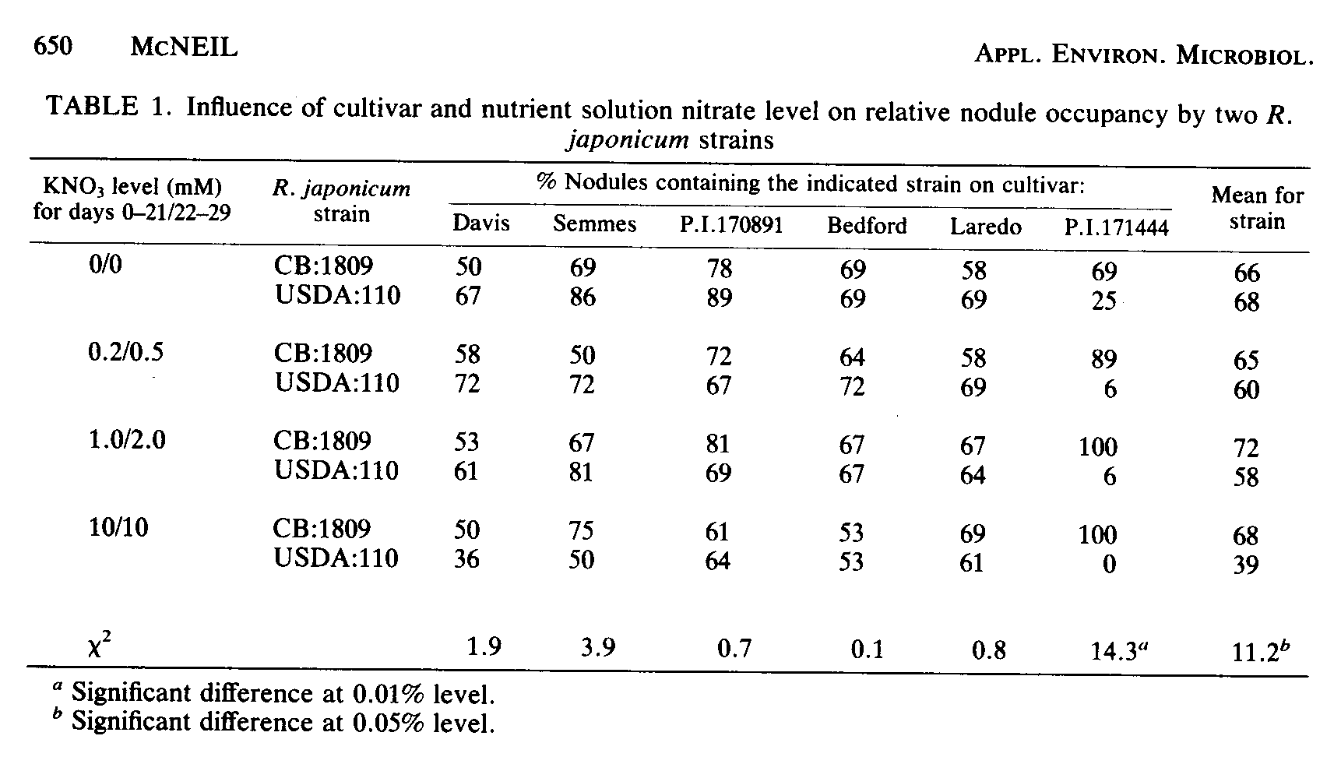
was used as an inoculant, the percentage of nodules formed by that strain declined from 16 to 0% on four soil types. This decline corresponded with an increase in the reliance of the crop on soil nitrogen. Competitiveness in the presence of soil nitrate may therefore be an essential characteristic in choosing strains for inoculation into soils containing appreciable nitrate.
Of the two screening methods used, the testing for varieties that nodulate early in the continuous presence of moderate levels (1.5 mM) of nitrate was more successful than the testing of nitrate effects on established symbioses. Substantial differences in nitrate sensitivities were only noted at low to moderate (0.2 to 2.0 mM) levels of nitrate. A 10 mM nitrate concentration had equally deleterious effects on all of the strains tested. Soybean cultivars (D. L. McNeil, unpublished data) also show differences in symbiotic sensitivities over this range and no differences at the highest levels.
Only a limited range of sensitivity to nitrate was found in the tested germplasm. Of the strains tested, CB:1809 performed significantly better under a variety of external nitrate conditions and testing situations. Its competitiveness for infection sites improved in high-nitrate conditions; it gave greater nodule and plant yields when some nitrate was present, and it produced nodules as rapidly as any of the strains tested in culture solutions containing 1.5 mM nitrate. Thus, there is some benefit to be gained from screening strains for reaction to external nitrate.
Random testing of strains to determine the sensitivity to nitrate of their symbioses seems to be an ineffective selection method. Application of selection pressure on populations of R. japonicum would appear to be a more efficient method for specific improvement of strains, particularly since isolines capable of delimiting the importance of this characteristic could be produced by this method. One such method has been used effectively on R. lupinii (10). An alternative
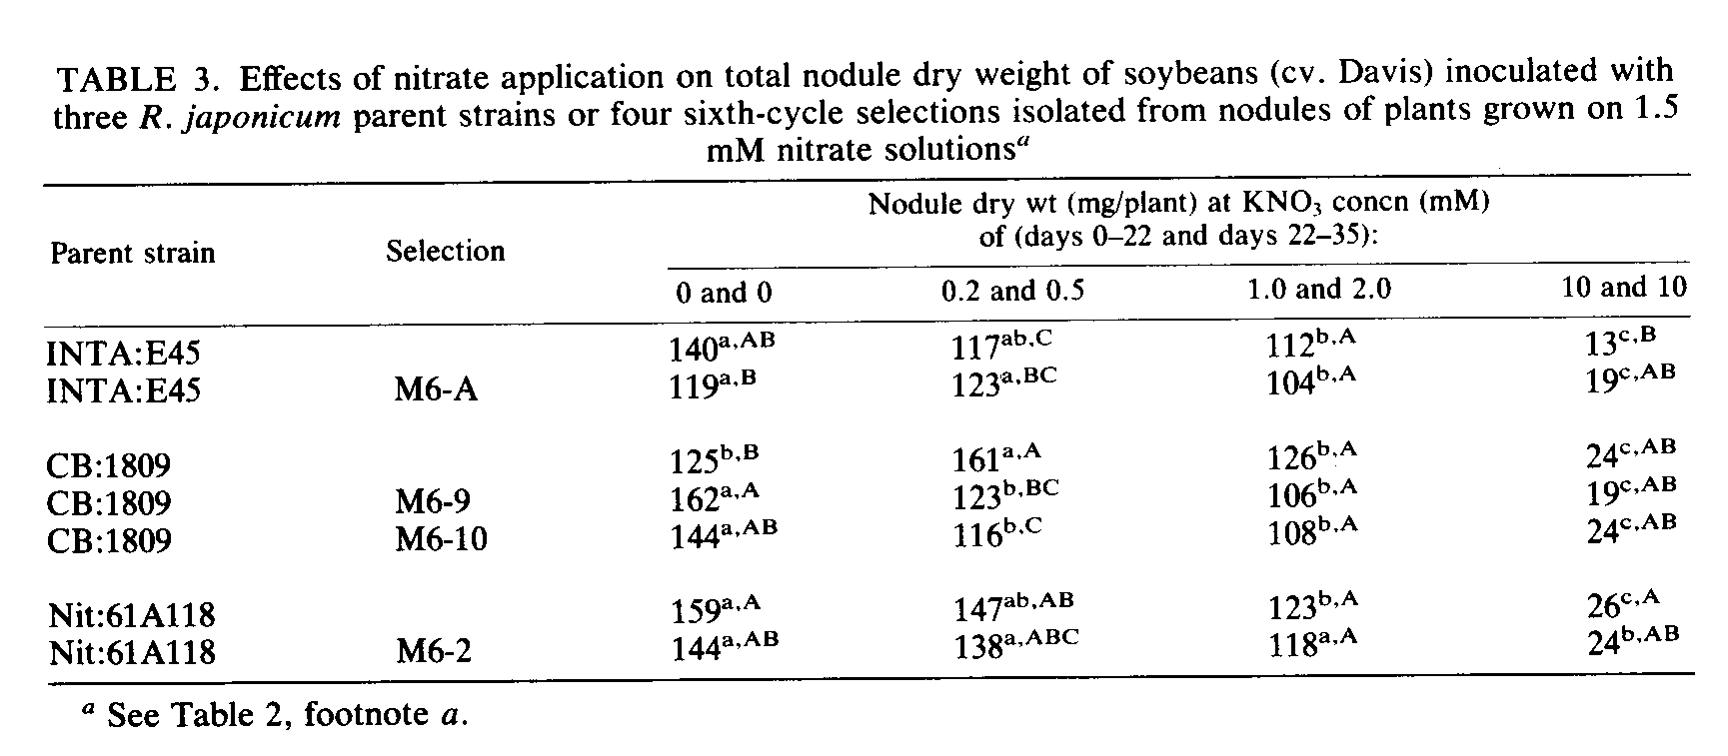
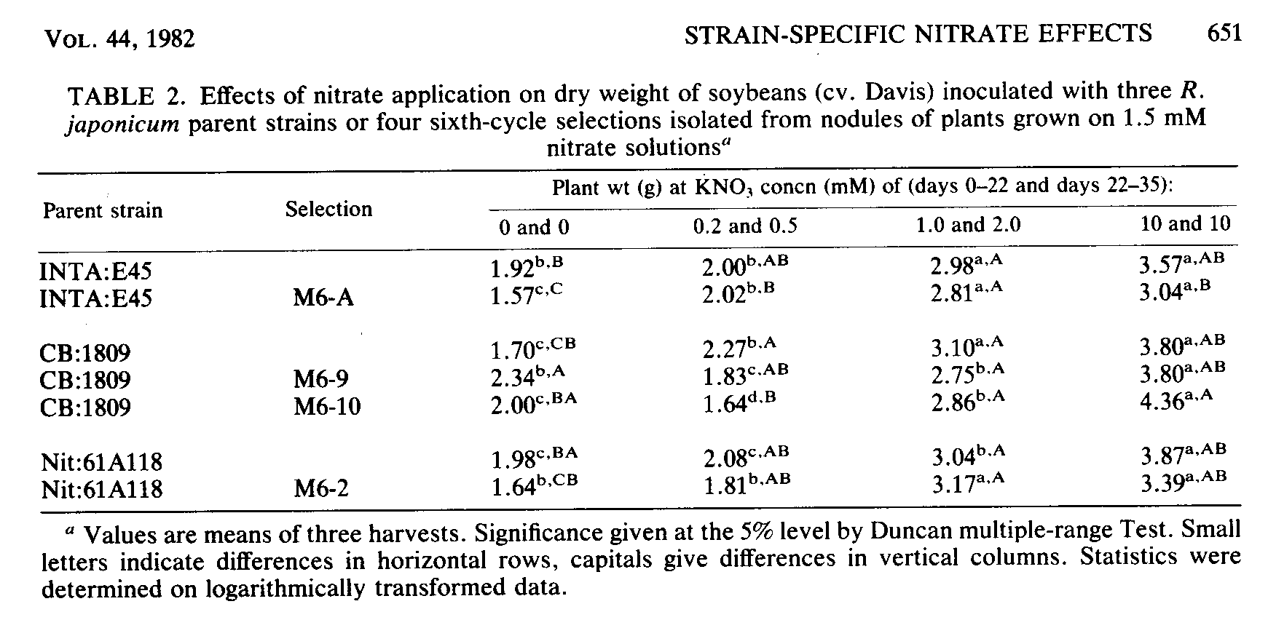
652 McNEIL

method was tested here by using the plant as the vehicle for selection. Unfortunately, nitrogen-adapted substrains did not result. The isolations did produce symbioses with altered sensitivities of their nitrogen fixation to nitrate. However, these symbioses were more, not less, affected by external nitrate.
The data given here indicate that some strain variation in the sensitivity of soybean symbioses to nitrate does exist; however, the presently known variation seems insufficient to lead to a substantial field benefit. The simple and direct method used here for selecting nitrogen-adapted substrains did not accomplish the desired objective and needs further improvement before its continued use would be warranted. Indeed, present evidence suggests that work on the plant would be a more fruitful approach to overcoming nitrate inhibition of fixation. A parallel study with soybean cultivars and mutants indicated a greater potential in this route, and these data will be published elsewhere.
ACKNOWLEDGMENT

This work was performed under U.S. Agency for International Development contract ta-C-1207 (NifTAL Project).

LITERATURE CITED

1. Broughton, W. J., and M. J. Dilworth. 1971. Control of leghaemoglobin synthesis in snake beans. Biochem. J. 125:1075-1080.
2. Cataldo, D. A., M. Haroon, L. E. Shrader, and V. L. Young. 1975. Rapid colorimetric determination of nitrate in plant tissues by nitration of salicylic acid. Commun. Soil. Sci. Plant Anal. 6:71-80.
3. Gibson, A. H. 1976. Recovery and compensation by nodulated legumes to environmental stress p. 385-403. In P. S. Nutman (ed.), Symbiotic nitrogen fixation in plants. Cambridge University Press, London.
4. Gibson, A. H., N. F. Dudman, R. W. Weaver, J. C. Norton, and I. C. Anderson. 1971. Variation within serogroup 123 of Rhizobium japonicum p. 33-37. In T. A. Lie and E. G. Mulder (ed.), Plant and soil special volume. Martinus Nijhoff Ltd., The Hague.
APPL. ENVIRON. MICROBIOL.

5. Ham, G. E., L. R. Frederick, and I. C. Anderson. 1971. Serogroups of Rhizobium japonicum in soybean nodules sampled in Iowa. Agron. J. 63:69-72.
6. Harris, S. (ed.). 1979. International network of legume inoculation trials, experimental manual. NifTAL Project, Paia, Maui, Hawaii.
7. Heichel, G. H., and C. P. Vance. 1979. Nitrate N and Rhizobium strain roles in alfalfa seedling nodulation and growth. Crop Sci. 19:512-518.
8. Johnson, J. W., L. F. Welch, and L. T. Kurtz. 1975. Environmental implications of N fixation by soybeans. J. Environ. Qual. 4:303-306.
9. Lawn, R. J., and W. A. Brun. 1974. Symbiotic nitrogen fixation in soybean. Crop Sci. 14:22-25.
10. Manhart, J., and P. P. Wong. 1980. Nitrate effect on nitrogen fixation (acetylene reduction). Plant Physiol. 65:502-505.
11. Munns, D. N. 1977. Mineral nutrition and legume symbiosis p. 353-391. In R. W. F. Hardy and A. H. Gibson (ed.), A treatise on dinitrogen fixation section IV: agronomy and ecology. John Wiley & Sons, New York.
12. Pal, U. R., and M. C. Saxena. 1976. Relationship between nitrogen analysis of soybean tissues and soybean yield. Agron. J. 6:927-932.
13. Pate, J. S., and P. J. Dart. 1961. Nodulation studies in legumes IV. The influence of inoculum strain and time of application of ammonium nitrate on symbiotic response. Plant and Soil 15:329-346.
14. Somasegaran, P., H. Hoben, and J. Halliday. 1979. Practical exercises in legume/Rhizobium technology. NifTAL Project, Paia, Maui, Hawaii.
15. Somasegaran, P., R. Woolfenden, and J. Halliday. 1981. Methods of preserving legume root nodules for serological typing, p. 14. Proceedings of the Eighth North American Rhizobium Conference. University of Manitoba, Winnipeg, Canada.
16. Trinick, M. J. 1969. Identification of legume nodule bacteroids by the fluorescent antibody reaction. J. Appl. Bacteriol. 32:181-186.
17. Weber, C. R. 1966. Nodulating and non-nodulatiog soybean isolines II response to applied N. Agron. J. 58:4649.
18. Welch, L. F., L. V. Boone, C. G. Chamblis, A. T. Christiansen, D. L. Mulvaney, M. C. Oldham, and J. W. Pen-d eton. 1973. Soybean l yields with direct and residual N fertilization. Agron. J. 65:547-550.
19. Wych, R. D., and D. W. Rains. 1979. Nitrate absorbtion and acetylene reduction by soybeans during reproductive development. Physiol. Plant. 47:200-204.

